LAB-4

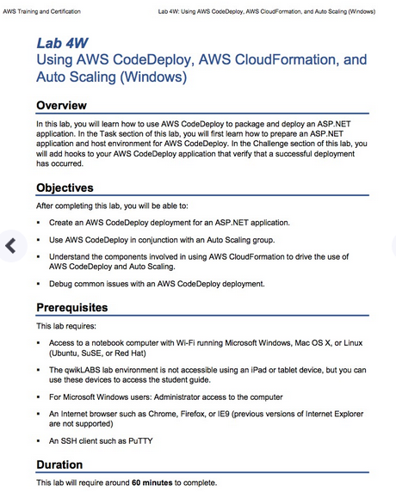

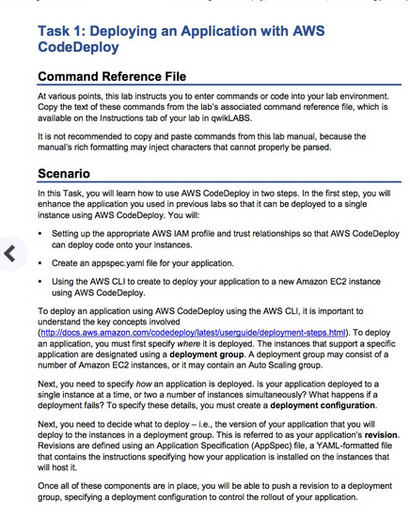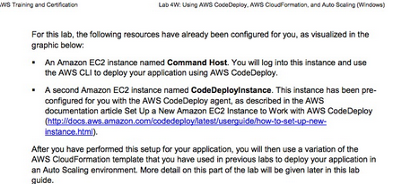

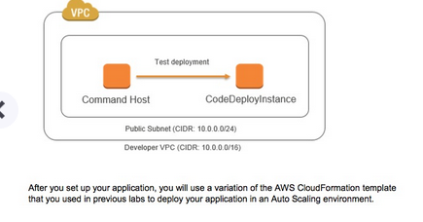

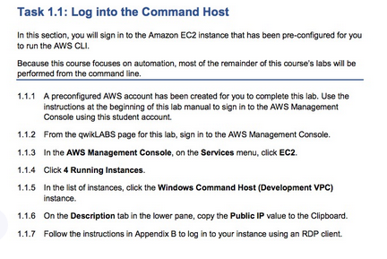

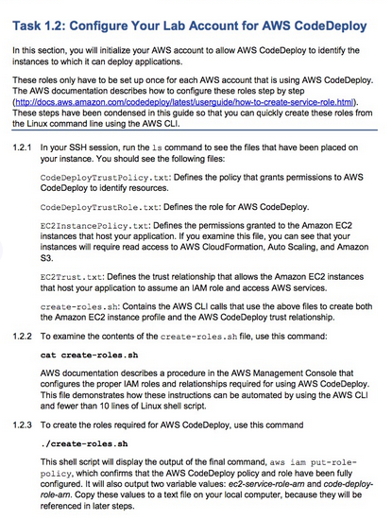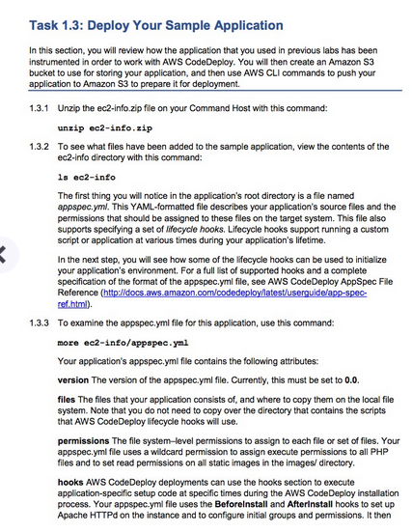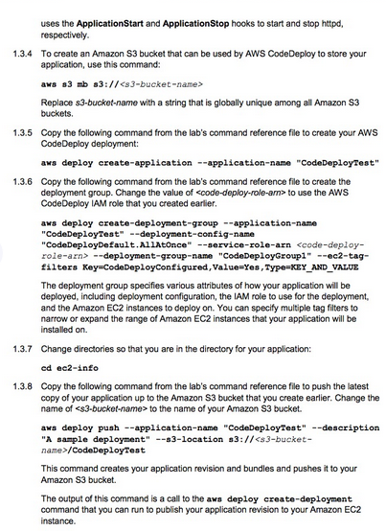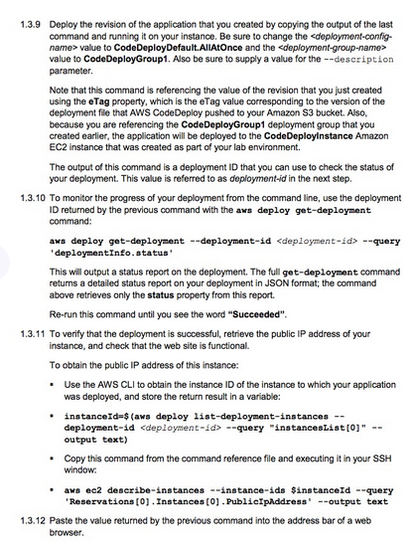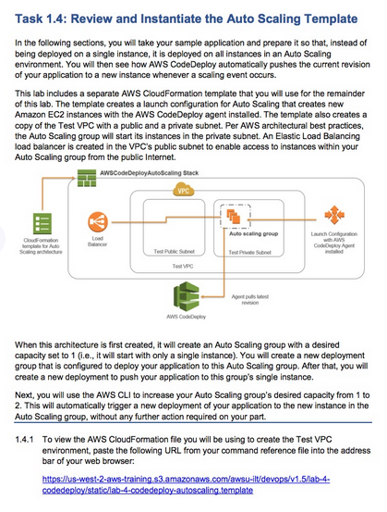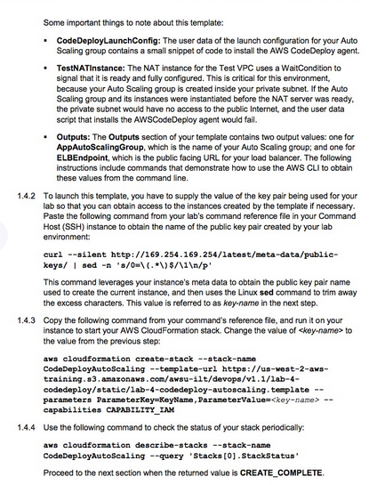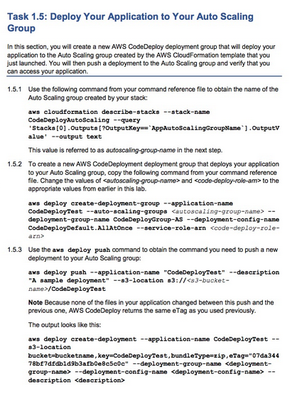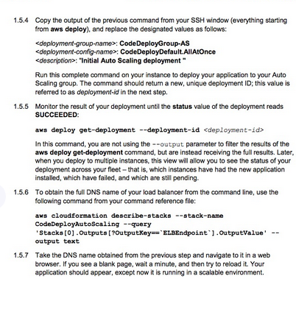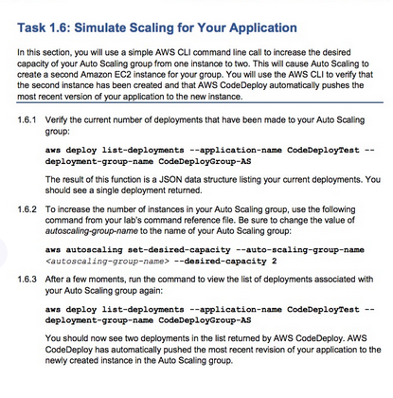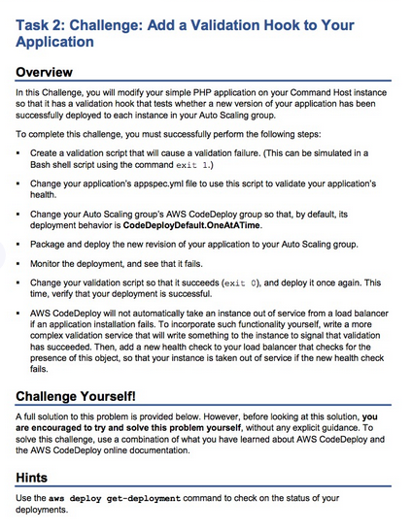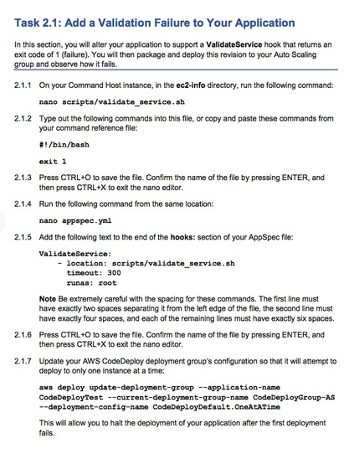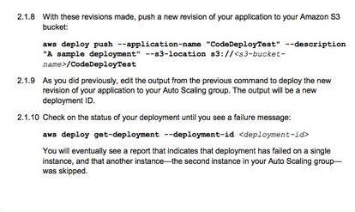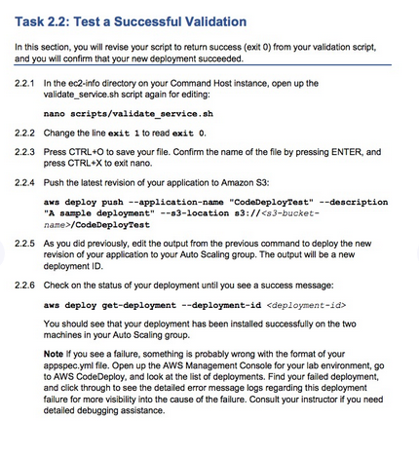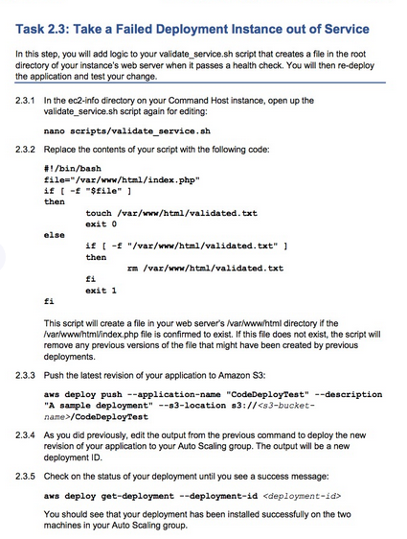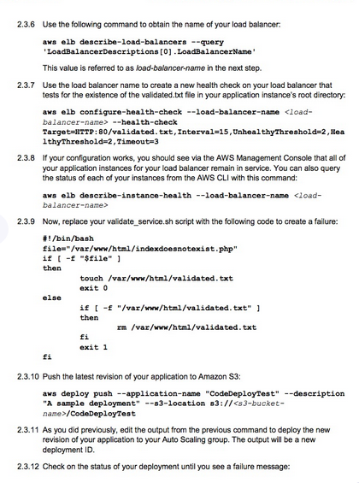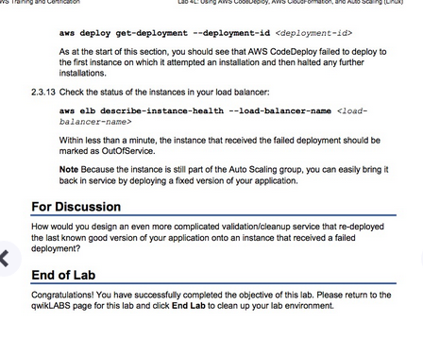DevOps Engineering on AWS: Lab 4 - Using AWS CodeDeploy, AWS CloudFormation, and Auto Scaling - v1.5

==================================================================================================================

Using this command reference.

==================================================================================================================

1. Locate the section you need. Each section in this file matches a section in the lab instructions.

2. Replace items in angle brackets - < > - with appropriate values. For example, in this command you would replace the value - <JobFlowID> - (including the angle brackets) with the parameter indicated in the lab instructions:

elastic-mapreduce --list <JobFlowID>. You can also use find and replace to change bracketed parameters in bulk.

3. Do NOT enable the Word Wrap feature in Windows Notepad or the text editor you use to view this file.

++++1. Task: Deploying an Application with AWS CodeDeploy

==================================================================================================================

1.2: Configure Your Lab Account for AWS CodeDeploy

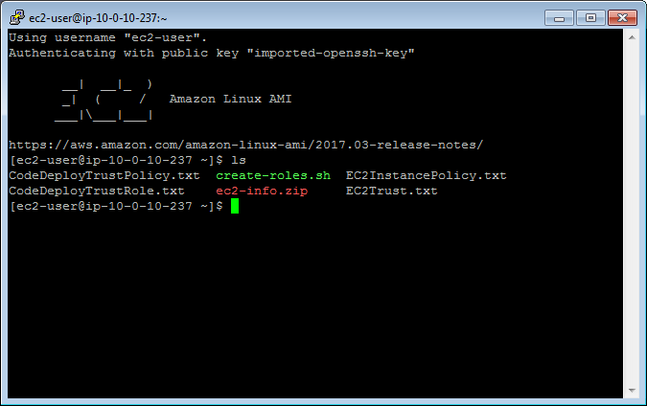

1.2.2 Examine the contents of the create-roles.sh file

cat create-roles.sh

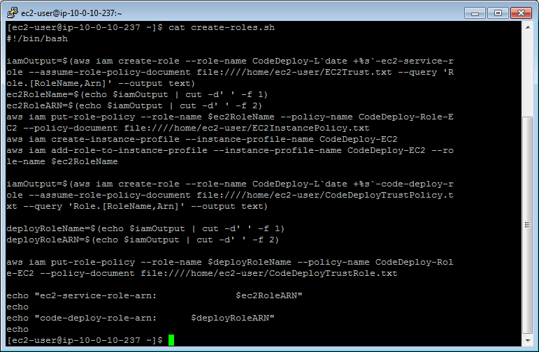

1.2.3 Create the roles required for AWS CodeDeploy

./create-roles.sh

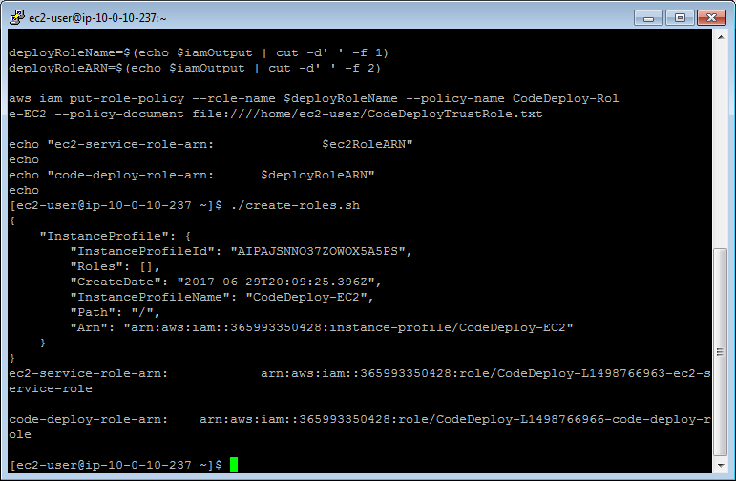

ec2-service-role-arn: arn:aws:iam::365993350428:role/CodeDeploy-L1498766963-ec2-service-role

code-deploy-role-arn: arn:aws:iam::365993350428:role/CodeDeploy-L1498766966-code-deploy-role

==================================================================================================================

1.3 Deploy Your Sample Application

==================================================================================================================

1.3.1 Unzip the ec2-info.zip file

unzip ec2-info.zip

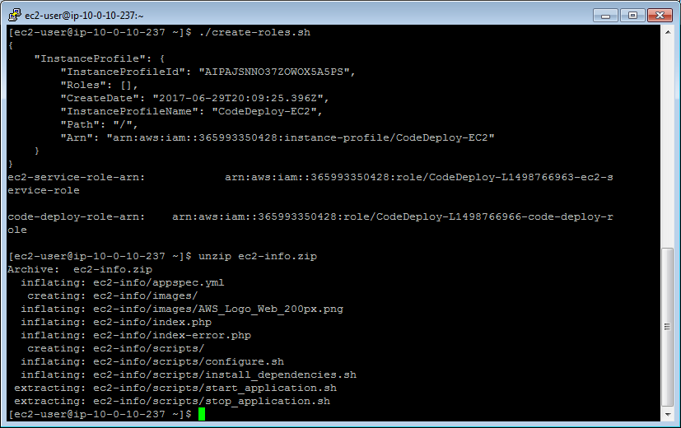

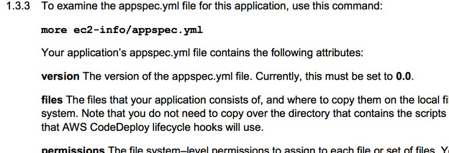

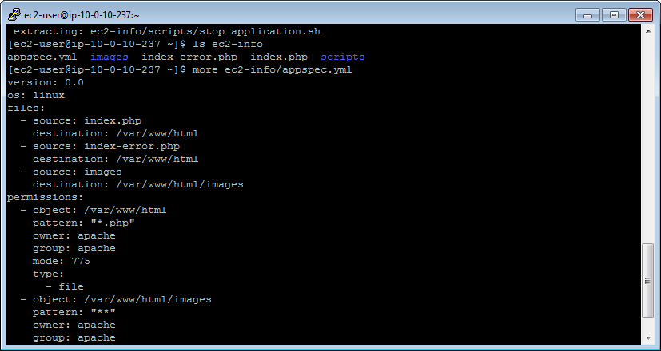

1.3.4 Create an Amazon S3 bucket

aws s3 mb s3://<s3-bucket-name>

aws s3 mb s3://shwetamis

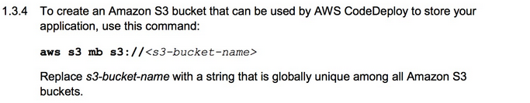

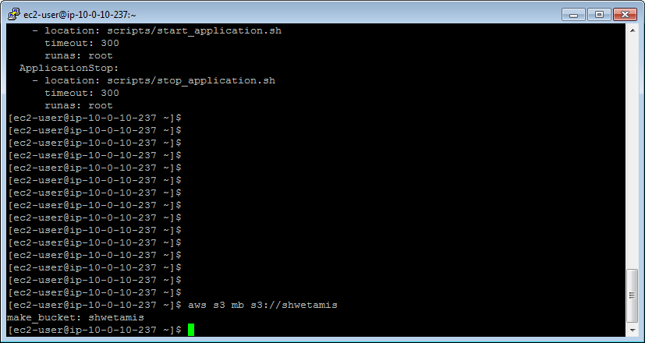

1.3.5 Create your AWS CodeDeploy deployment

aws deploy create-application --application-name "CodeDeployTest"

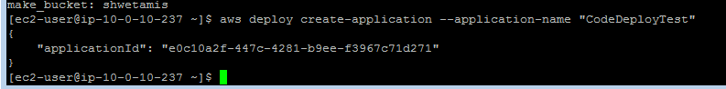

1.3.6 Create the deployment group

aws deploy create-deployment-group --application-name "CodeDeployTest" --deployment-config-name "CodeDeployDefault.AllAtOnce" --service-role-arn <code-deploy-role-arn> --deployment-group-name "CodeDeployGroup1" --ec2-tag-filters Key=CodeDeployConfigured,Value=Yes,Type=KEY_AND_VALUE

cmd: aws deploy create-deployment-group --application-name "CodeDeployTest" --deployment-config-name "CodeDeployDefault.AllAtOnce" --service-role-arn arn:aws:iam::365993350428:role/CodeDeploy-L1498766966-code-deploy-role --deployment-group-name "CodeDeployGroup1" --ec2-tag-filters Key=CodeDeployConfigured,Value=Yes,Type=KEY_AND_VALUE

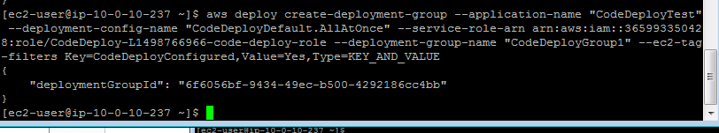

1.3.8 Bundle and push your application to Amazon S3

aws deploy push --application-name "CodeDeployTest" --description "A sample deployment" --s3-location s3://<s3-bucket-name>/CodeDeployTest

aws deploy push --application-name "CodeDeployTest" --description "A sample deployment" --s3-location s3://shwetamis/CodeDeployTest

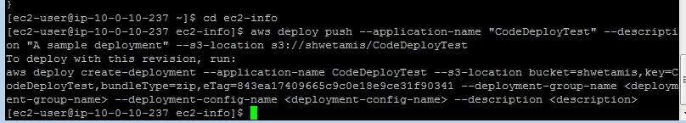

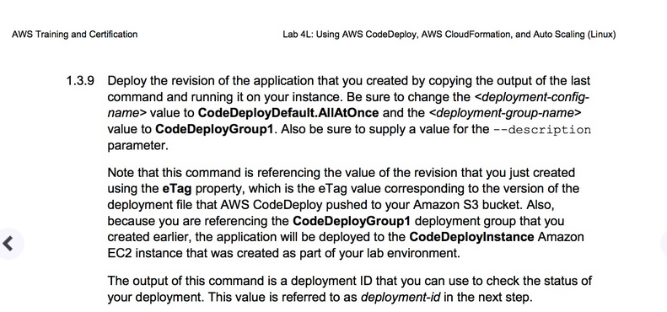

[ec2-user@ip-10-0-10-237 ec2-info]$ aws deploy create-deployment --application-name CodeDeployTest --s3-location bucket=shwetamis,key=CodeDeployTest,bundleType=zip,eTag=843ea17409665c9c0e18e9ce31f90341 --deployment-group-name "CodeDeployGroup1" --deployment-config-name "CodeDeployDefault.AllAtOnce" --description "shwetaTesting"

{

"deploymentId": "d-6YQRIZ04N"

}

[ec2-user@ip-10-0-10-237 ec2-info]$

1.3.10 Track status of deployment

aws deploy get-deployment --deployment-id <deployment-id> --query 'deploymentInfo.status'

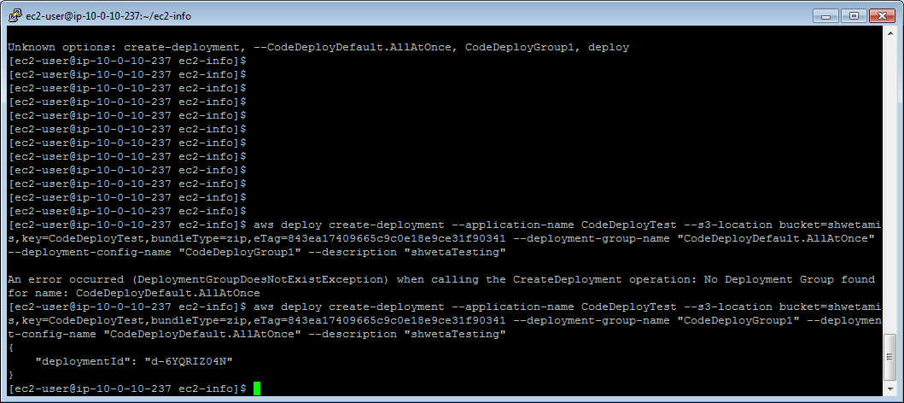

1.3.11a Obtain the instance ID to which your application was deployed

instanceId=$(aws deploy list-deployment-instances --deployment-id <deployment-id> --query "instancesList[0]" --output text)

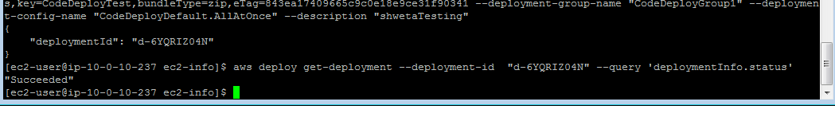

1.3.11b Obtain the value of the public IP address

aws ec2 describe-instances --instance-ids $instanceId --query 'Reservations[0].Instances[0].PublicIpAddress' --output text

[ec2-user@ip-10-0-10-237 ec2-info]$ aws deploy get-deployment --deployment-id "d-6YQRIZ04N" --query 'deploymentInfo.status'

"Succeeded"

[ec2-user@ip-10-0-10-237 ec2-info]$ instanceId=$(aws deploy list-deployment-instances --deployment-id "d-6YQRIZ04N" --query "instancesList[0]" --output text)

[ec2-user@ip-10-0-10-237 ec2-info]$ aws ec2 describe-instances --instance-ids $instanceId --query 'Reservations[0].Instances[0].PublicIpAddress' --output text

34.210.119.122

[ec2-user@ip-10-0-10-237 ec2-info]$

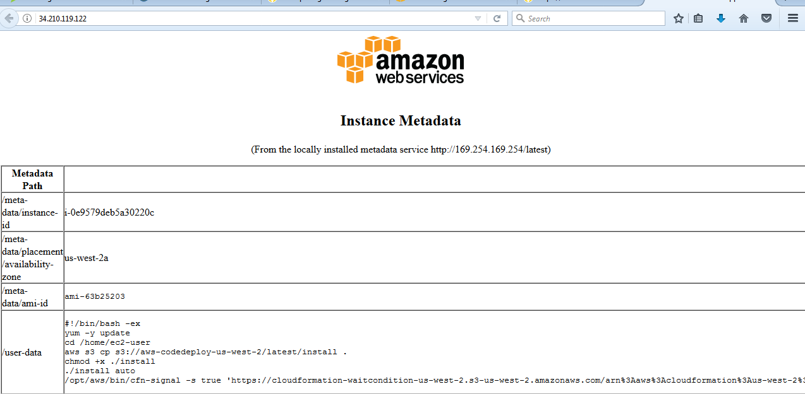

==================================================================================================================

1.4 Review and Instantiate the Auto Scaling Template

==================================================================================================================

1.4.1 View AWS CloudFormation template

https://us-west-2-aws-training.s3.amazonaws.com/awsu-ilt/devops/v1.5/lab-4-codedeploy/static/lab-4-codedeploy-autoscaling.template

1.4.2 Get current key name

curl --silent http://169.254.169.254/latest/meta-data/public-keys/ | sed -n 's/0=\(.*\)$/\1\n/p'



[ec2-user@ip-10-0-10-237 ec2-info]$ curl --silent http://169.254.169.254/latest/meta-data/public-keys/ | sed -n 's/0=\(.*\)$/\1\n/p'

qwikLABS-L663-147482

[ec2-user@ip-10-0-10-237 ec2-info]$

1.4.3 Start up your Test VPC environment

aws cloudformation create-stack --stack-name CodeDeployAutoScaling --template-url https://us-west-2-aws-training.s3.amazonaws.com/awsu-ilt/devops/v1.5/lab-4-codedeploy/static/lab-4-codedeploy-autoscaling.template --parameters ParameterKey=KeyName,ParameterValue=<key-name> --capabilities CAPABILITY_IAM

CMD: aws cloudformation create-stack --stack-name CodeDeployAutoScaling --template-url https://us-west-2-aws-training.s3.amazonaws.com/awsu-ilt/devops/v1.5/lab-4-codedeploy/static/lab-4-codedeploy-autoscaling.template --parameters ParameterKey=KeyName,ParameterValue="qwikLABS-L663-147482" --capabilities CAPABILITY_IAM

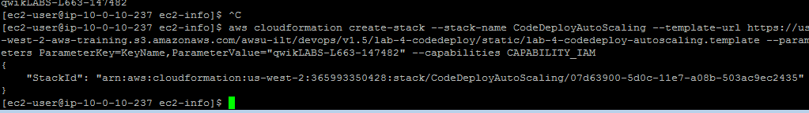

1.4.4 Check the status of your stack

aws cloudformation describe-stacks --stack-name CodeDeployAutoScaling --query 'Stacks[0].StackStatus'

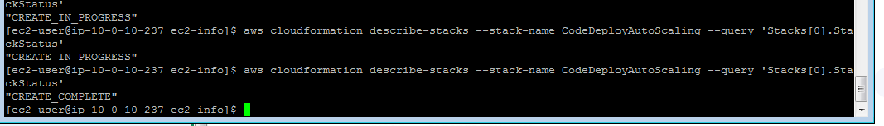

==================================================================================================================

1.5 Deploy Your Application to an Auto Scaling Group

==================================================================================================================

1.5.1 Get name of auto scaling group from stack

aws cloudformation describe-stacks --stack-name CodeDeployAutoScaling --query 'Stacks[0].Outputs[?OutputKey==`AppAutoScalingGroupName`].OutputValue' --output text

[ec2-user@ip-10-0-10-237 ec2-info]$ aws cloudformation describe-stacks --stack-name CodeDeployAutoScaling --query 'Stacks[0].Outputs[?OutputKey==`AppAutoScalingGroupName`].OutputValue' --output text

CodeDeployAutoScaling-AppAutoScalingGroup-1RVXOTME4RUY7

[ec2-user@ip-10-0-10-237 ec2-info]$



1.5.2 Create a new deployment group

aws deploy create-deployment-group --application-name CodeDeployTest --auto-scaling-groups <autoscaling-group-name> --deployment-group-name CodeDeployGroup-AS --deployment-config-name CodeDeployDefault.AllAtOnce --service-role-arn <code-deploy-role-arn>

aws deploy create-deployment-group --application-name CodeDeployTest --auto-scaling-groups "CodeDeployAutoScaling-AppAutoScalingGroup-1RVXOTME4RUY7" --deployment-group-name CodeDeployGroup-AS --deployment-config-name CodeDeployDefault.AllAtOnce --service-role-arn "arn:aws:iam::365993350428:role/CodeDeploy-L1498766966-code-deploy-role"

CMD: "CodeDeployAutoScaling-AppAutoScalingGroup-1RVXOTME4RUY7" --deployment-group-name CodeDeployGroup-AS --deployment-config-name CodeDeployDefault.AllAtOnce --service-role-arn "arn:aws:iam::365993350428:role/CodeDeploy-L1498766966-code-deploy-role"

{

"deploymentGroupId": "9ca24899-fa2c-4b2f-bca0-1bc2c33a4744"

}

[ec2-user@ip-10-0-10-237 ec2-info]$

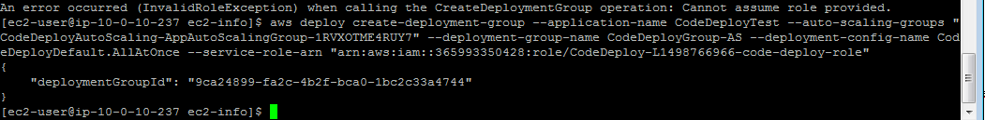

1.5.3 Execute the push again to get the deployment command

aws deploy push --application-name "CodeDeployTest" --description "A sample deployment" --s3-location s3://<s3-bucket-name>/CodeDeployTest

[ec2-user@ip-10-0-10-237 ec2-info]$ aws deploy push --application-name "CodeDeployTest" --description "A sample deployment" --s3-location s3://shwetamis/CodeDeployTest

To deploy with this revision, run:

aws deploy create-deployment --application-name CodeDeployTest --s3-location bucket=shwetamis,key=CodeDeployTest,bundleType=zip,eTag=1239ed24fc668015ba6a518e879b6a4a --deployment-group-name <deployment-group-name> --deployment-config-name <deployment-config-name> --description <description>

[ec2-user@ip-10-0-10-237 ec2-info]$



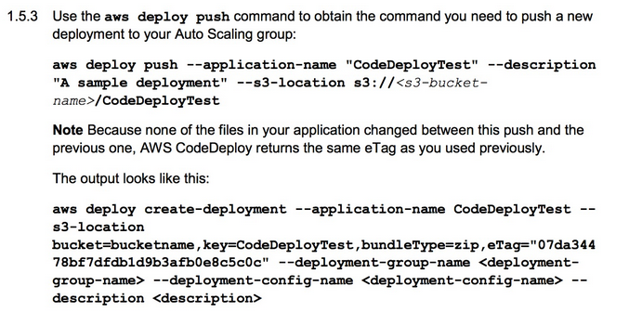 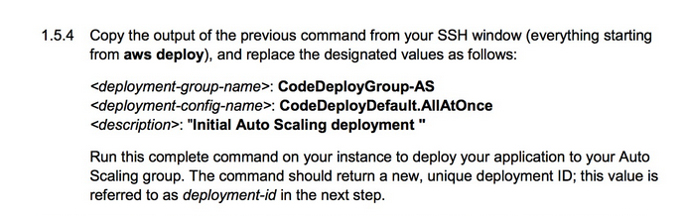

"deploymentId": "d-VTEE3VV3N"



1.5.5 Monitor the status of your deployment

aws deploy get-deployment --deployment-id <deployment-id>

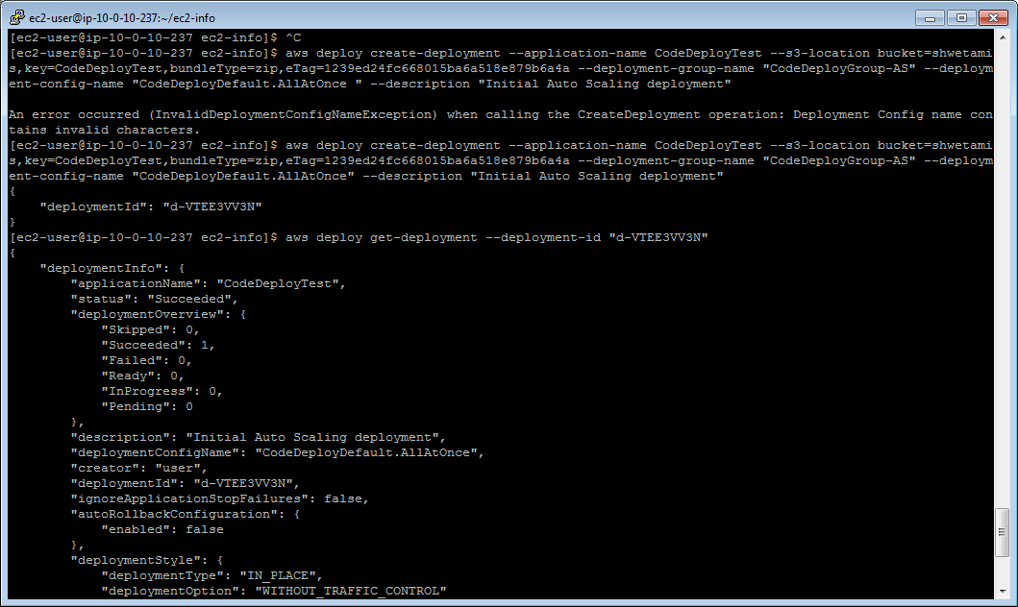

1.5.6 Obtain the endpoint of the ELB

aws cloudformation describe-stacks --stack-name CodeDeployAutoScaling --query 'Stacks[0].Outputs[?OutputKey==`ELBEndpoint`].OutputValue' --output text



RESULT: CodeDeplo-AppLoadB-1KTS5RX4HBIIM-1655742020.us-west-2.elb.amazonaws.com

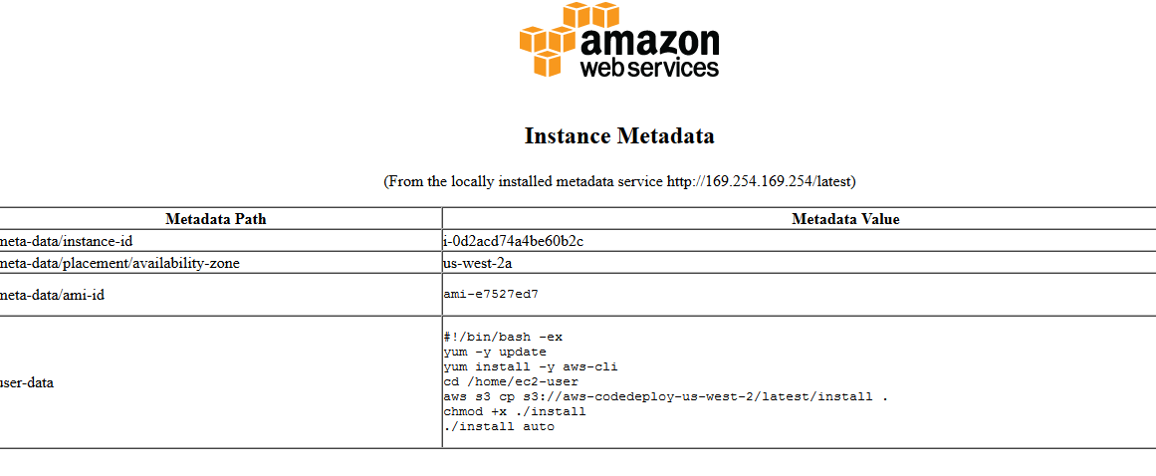

==================================================================================================================

1.6 Simulate Scaling on Your AWS CodeDeploy Application

==================================================================================================================

1.6.1 List the current number of deployments for your Auto Scaling deployment group

aws deploy list-deployments --application-name CodeDeployTest --deployment-group-name CodeDeployGroup-AS

[ec2-user@ip-10-0-10-237 ec2-info]$ aws deploy list-deployments --application-name CodeDeployTest --deployment-group-name CodeDeployGroup-AS

{

"deployments": [

"d-VTEE3VV3N"

]

}

[ec2-user@ip-10-0-10-237 ec2-info]$

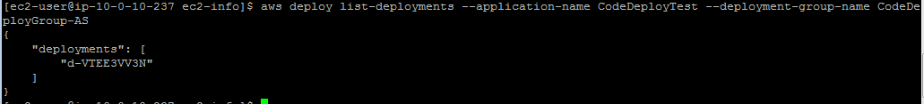

1.6.2 Change the desired capacity for the Auto Scaling group

aws autoscaling set-desired-capacity --auto-scaling-group-name <autoscaling-group-name> --desired-capacity 2

aws autoscaling set-desired-capacity --auto-scaling-group-name "CodeDeployAutoScaling-AppAutoScalingGroup-1RVXOTME4RUY7" --desired-capacity 2



1.6.3 Verify the number of deployments

aws deploy list-deployments --application-name CodeDeployTest --deployment-group-name CodeDeployGroup-AS

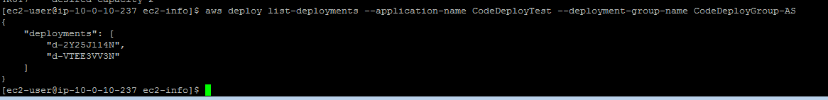

++++2. Challenge: Verify Your Deployment

==================================================================================================================

2.1 Add a Validation Failure to Your Application

==================================================================================================================

2.1.1 Open up the validate_service.sh script for editing

nano scripts/validate_service.sh

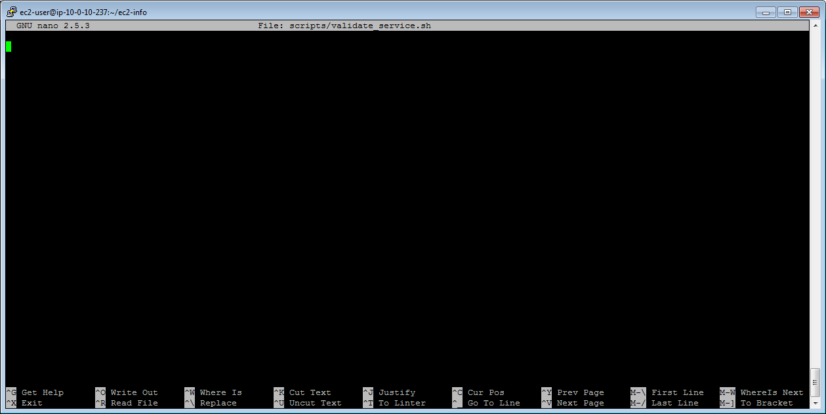

2.1.2 Copy the following file into validate_service.sh

#!/bin/bash

exit 1

2.1.5 Add the following to appspec.yml

ValidateService:

- location: scripts/validate_service.sh

timeout: 300

runas: root

2.1.7 Change deployment config default

aws deploy update-deployment-group --application-name CodeDeployTest --current-deployment-group-name CodeDeployGroup-AS --deployment-config-name CodeDeployDefault.OneAtATime

2.1.8 Push new revision

aws deploy push --application-name "CodeDeployTest" --description "A sample deployment" --s3-location s3://<s3-bucket-name>/CodeDeployTest

aws deploy push --application-name "CodeDeployTest" --description "A sample deployment" --s3-location s3://shwetamis/CodeDeployTest



aws deploy create-deployment --application-name CodeDeployTest --s3-location bucket=shwetamis,key=CodeDeployTest,bundleType=zip,eTag=4952b0e07e642aecfb62845976c020ab --deployment-group-name <deployment-group-name> --deployment-config-name <deployment-config-name> --description <description>

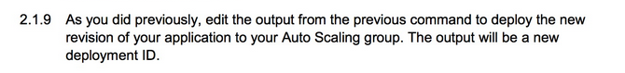



"deploymentId": "d-F5151OW3N"

2.1.10 Check on the status of your deployment

aws deploy get-deployment --deployment-id "d-F5151OW3N"

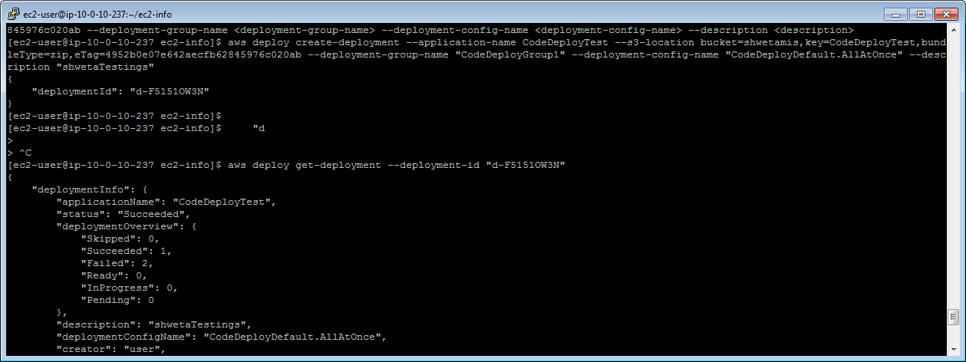

==================================================================================================================

2.2 Test a Successful Validation

==================================================================================================================

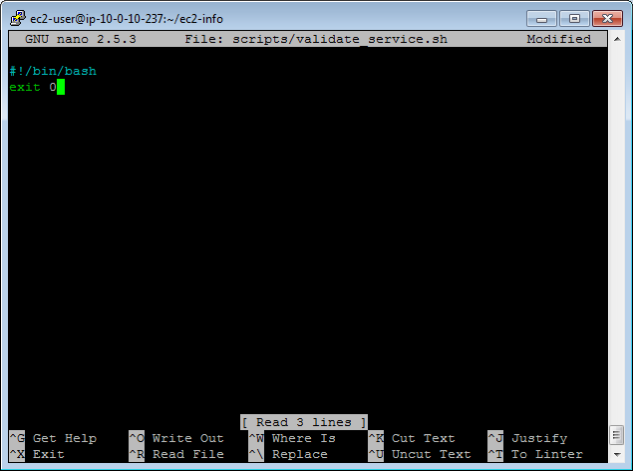

2.2.4 Push your latest revision

aws deploy push --application-name "CodeDeployTest" --description "A sample deployment" --s3-location s3://<s3-bucket-name>/CodeDeployTest

[ec2-user@ip-10-0-10-237 ec2-info]$ aws deploy create-deployment --application-name CodeDeployTest --s3-location bucket=shwetamis,key=CodeDeployTest,bundleType=zip,eTag=7d05227bf53ee6b3e7593c93d8fe12bb --deployment-group-name "CodeDeployGroup1" --deployment-config-name "CodeDeployDefault.AllAtOnce" --description "shwetatesting"

{

"deploymentId": "d-0XM44KY3N"

}

[ec2-user@ip-10-0-10-237 ec2-info]$

2.2.6 Check on the status of your deployment

aws deploy get-deployment --deployment-id "d-0XM44KY3N"

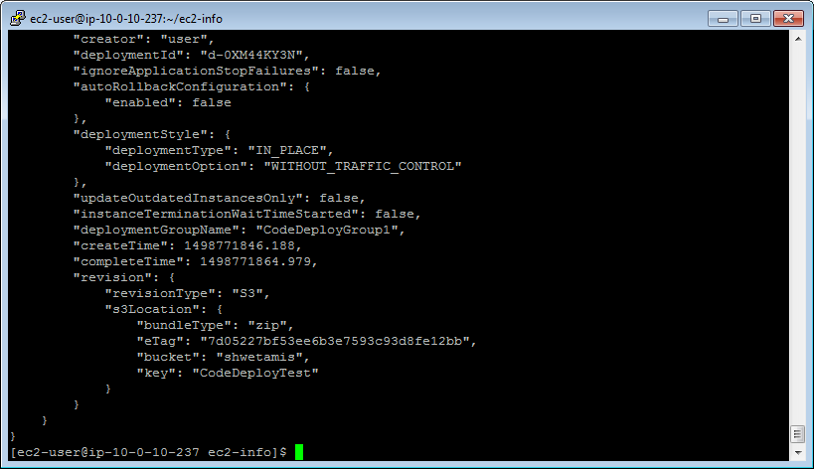

==================================================================================================================

2.3 Test a Successful Validation

==================================================================================================================

2.3.2 Create a more detailed validate_service.sh script

#!/bin/bash

file="/var/www/html/index.php"

if [ -f "$file" ]

then

touch /var/www/html/validated.txt

exit 0

else

if [ -f "/var/www/html/validated.txt" ]

then

rm /var/www/html/validated.txt

fi

exit 1

fi

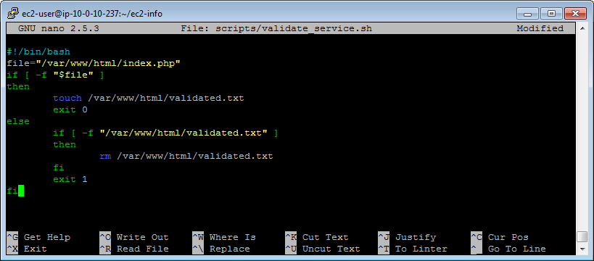

2.3.3 Push your latest revision

aws deploy push --application-name "CodeDeployTest" --description "A sample deployment" --s3-location s3://<s3-bucket-name>/CodeDeployTest

[ec2-user@ip-10-0-10-237 ec2-info]$ aws deploy create-deployment --application-name CodeDeployTest --s3-location bucket=shwetamis,key=CodeDeployTest,bundleType=zip,eTag=d379e840ea13c557d503c855c98f85c3 --deployment-group-name "CodeDeployGroup1" --deployment-config-name "CodeDeployDefault.AllAtOnce" --description "shwetatesting"

{

"deploymentId": "d-CHNTH5X3N"

}

[ec2-user@ip-10-0-10-237 ec2-info]$

2.3.5 Check deployment status

aws deploy get-deployment --deployment-id "d-CHNTH5X3N"

2.3.6 Obtain the name of your load balancer

aws elb describe-load-balancers --query 'LoadBalancerDescriptions[0].LoadBalancerName'

[ec2-user@ip-10-0-10-237 ec2-info]$ aws elb describe-load-balancers --query 'LoadBalancerDescriptions[0].LoadBalancerName'

"CodeDeplo-AppLoadB-1KTS5RX4HBIIM"

[ec2-user@ip-10-0-10-237 ec2-info]$

2.3.7 Configure a new health check

aws elb configure-health-check --load-balancer-name "CodeDeplo-AppLoadB-1KTS5RX4HBIIM"--health-check Target=HTTP:80/validated.txt,Interval=15,UnhealthyThreshold=2,HealthyThreshold=2,Timeout=3

2.3.8 Describe the health of your load balancers

aws elb describe-instance-health --load-balancer-name <load-balancer-name>

aws cloudformation create-stack --stack-name CodeDeployAutoScaling --template-url https://us-west-2-aws-training.s3.amazonaws.com/awsu-ilt/devops/v1.5/lab-4-codedeploy/static/lab-4-codedeploy-autoscaling.template --parameters ParameterKey=KeyName,ParameterValue="qwikLABS-L663-147482" --capabilities CAPABILITY_IAM

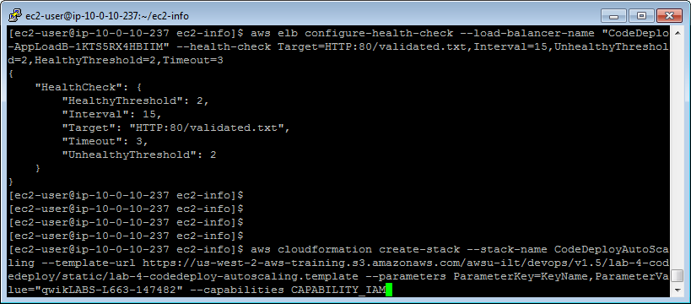

2.3.9 Create a failure

#!/bin/bash

file="/var/www/html/indexdoesnotexist.php"

if [ -f "$file" ]

then

touch /var/www/html/validated.txt

exit 0

else

if [ -f "/var/www/html/validated.txt" ]

then

rm /var/www/html/validated.txt

fi

exit 1

fi

2.3.10 Push your latest revision

aws deploy push --application-name "CodeDeployTest" --description "A sample deployment" --s3-location s3://<s3-bucket-name>/CodeDeployTest

2.3.12 Check deployment status

aws deploy get-deployment --deployment-id <deployment-id>

2.3.13 Check the status of your load balancer instances

aws elb describe-instance-health --load-balancer-name <load-balancer-name>

© 2017 Amazon Web Services, Inc. or its affiliates. All rights reserved.